**, tailing, building, ease, lengthy, diverted, disrupted, heavy, dense, die**

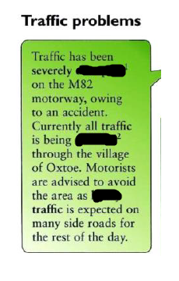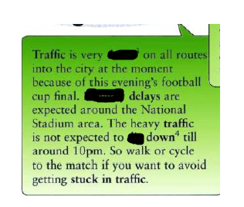

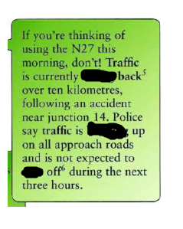



**clutch, wing mirror, accelerator , brake , dashboard, windscreen wipers, handbrake, windscreen , headlights**